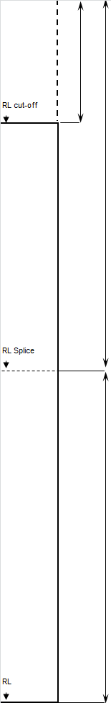

|  |  |  |  |  |  |  |
| --- | --- | --- | --- | --- | --- | --- |
| **Project No.** | | |  | |  | |
| Pile Type: | | | Yield Stress: | | Mpa | |
| Capacity kN: | calculated | | required | | | |
| Temporary Compression (C): | | | Mm measured | | | |
| Set mm: | | measured | required | | | |
| Hammer: mass | | tonnes | drop | metres | Efficiency % | |
| RL top of Pile: | | m | RL top of Pile: | | | m |
| Pile Length: m | | |

|  |  |  |  |  |  |  |  |
| --- | --- | --- | --- | --- | --- | --- | --- |
| **Pile Construction** | | | Date | Start Time | Finish Time | Hrs | Conditions |
| Pre-Drive / Bore / Jet | | |  |  |  |  |  |
| Drive No. | 1 | |  |  |  |  |  |
|  | | 2 |  |  |  |  |  |
|  | | 3 |  |  |  |  |  |
| Re Drive: | | |  |  |  |  |  |
| **Obstructions Encountered** | | | | | | | |
| Type: | | | | | | | |
| Depth: | | | | | | | |
| Action Taken: | | | | | | | |

|  |  |  |  |  |
| --- | --- | --- | --- | --- |
| **Date :** | **Time :** | **Penetration (m):** | **No. Of Blows** | **Comments** |
|  |  | **1** |  |  |
|  |  | **2** |  |  |
|  |  | **3** |  |  |
|  |  | **4** |  |  |
|  |  | **5** |  |  |
|  |  | **6** |  |  |
|  |  | **7** |  |  |
|  |  | **8** |  |  |
|  |  | **9** |  |  |
|  |  | **10** |  |  |
|  |  | **11** |  |  |
|  |  | **12** |  |  |
|  |  | **13** |  |  |
|  |  | **14** |  |  |
|  |  | **15** |  |  |
|  |  | **15.5** |  |  |
|  |  | **16** |  |  |
|  |  | **16.5** |  |  |
|  |  | **17** |  |  |
|  |  | **17.5** |  |  |
|  |  | **18** |  |  |

|  |  |  |
| --- | --- | --- |
| **The above works have been inspected and on the basis of this check sheet are considered compliant with the drawings, specifications and instructions.** | | |
| Name: Site Engineer | Sign: | Date: |
| Name: CPS Engineer - Geotechnical | Sign: | Date: |
| Name: CPS Engineer - Structural | Sign: | Date: |